Git And Github

Task 1:

1. Git Init

Initializes a new repo

1. Git add .

Adds all file to the staging area.



1. Git Status

Lists all files that are yet to be committed

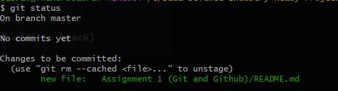

1. Git commit -m “”

records or snapshots the file permanently in the version history.

1. Git commit -a

This command commits any files you’ve added with the git add command and also commits any files you’ve changed since then.



1. Git branch -m main

Makes a new branch named main and switches to main branch



1. Git remote add origin

Obtain the git remote add URL for the remote repository and add credentials if needed.



1. Git push origin main

Pushes the files from origin to main branch.

1. Git switch / git checkout

Switches from one branch to another

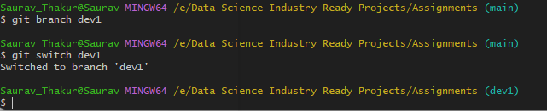

1. Git diff

git diff lists out the changes between your current working directory and your staging area.

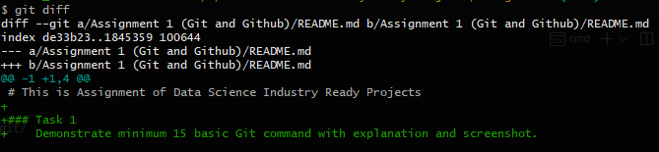

1. Git clone

Clones url in your current working directory

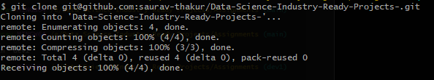

1. Git log

This command is used to list the version history for the current branch.

1. Git show

This command shows the metadata and content changes of the specified commit.

1. Git branch

List all the branches.

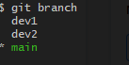

1. Git pull

This command fetches and merges changes on the remote server to your working directory.

Task 2:

https://github.com/saurav-thakur/Open-Source-Assignment

<https://saurav-thakur.github.io/Open-Source-Assignment/>

Task 3:

https://github.com/saurav-thakur/Task-3